

|  |  |  |  |  |  |
| --- | --- | --- | --- | --- | --- |
| **Programme** | : | B.Tech | **Semester** | : | WINTER SEM 21-22 |
| **Course** | : | Web Mining Lab | **Code** | : | CSE3024 |
| **Faculty** | : | Dr.Bhuvaneswari A | **Slot** | : | L7+L8 |
| **Time** | : | 8:00 PM to 9:30 PM | **Exam** | : | Challenging Task |
| **Date** | : | 05-04-2022 | **Marks** | : | 30 Marks |

**NAME: Dimish Pamnani**

**Reg No: 19BCE1407**

**Google Colab Link:** [**https://colab.research.google.com/drive/1Xpk27TH4R-xhVVXtWyHYKqw6sQCyD7R-?usp=sharing**](https://colab.research.google.com/drive/1Xpk27TH4R-xhVVXtWyHYKqw6sQCyD7R-?usp=sharing)

**CHALLENGING TASK - I**

**Answer any two questions (2 X 15 = 30 Marks)**

1. Write a Python program to classify the given twitter dataset describing tweets on U.S airlines into positive, neutral and negative classes. Use suitable Naïve Bayes classification technique. (dataset given).

* Apply Text pre-processing task
* Train and test the dataset
* Show the confusion matrix.
* Compute Accuracy, Precision, Recall and F-score.

**CODE:**

from enum import unique

import pandas as pd

import numpy as np

import re

all_words = []

word_size_class = {}

all_sents = []

word_frequency_label = {}

defload_data(filename):

data = pd.read_csv(filename)

test_index = data['airline_sentiment'] == '?'

training_data = data[-test_index]

testing_data = data[test_index]

testing_data.reset_index(inplace = True, drop = True)

return(training_data,testing_data)

deffind_vocab_size(training_data):

for index,sent inenumerate(training_data['text']):

ext_words = re.findall(r"([a-z0-9]+)",sent)

label = training_data['airline_sentiment'][index]

word_size_class[label] = word_size_class.get(label,0) + len(ext_words)

all_words.extend(ext_words)

all_sents.append(ext_words)

unique_words_count = len(set(all_words))

all_words_count = len(all_words)

global unique_words

unique_words = list(set(all_words))

return(unique_words_count,all_words_count)

deffind_prior_probabilties(training_data):

class_prior = {}

labels = training_data['airline_sentiment'].unique()

total = len(training_data)

for l in labels:

class_prior[l] = sum(training_data['airline_sentiment'] == l) / total

return class_prior

deffind_word_frequency_class(training_data):

for word in unique_words:

for index,sent_vec inenumerate(all_sents):

if word in sent_vec:

if word notin word_frequency_label:

word_frequency_label[word] = {}

label = training_data['airline_sentiment'][index]

word_frequency_label[word][label] = word_frequency_label[word].get(label,0) + sent_vec.count(word)

defdisplay_conditional_prob(vocab_size,labels):

i=0

for word in word_frequency_label:

for label in labels:

num = word_frequency_label[word].get(label,0) + 1

denom = word_size_class[label] + vocab_size

space = ""

print(f"P({word}/{label}) = {num}/{denom}{space*(14-len(word))}",end="\t")

print()

defdisplay_test_results(data,labels,vocab_size,class_prior):

for i,sent inenumerate(data['text']):

ext_words = re.findall(r"([a-z0-9]+)",sent)

probs = []

for label in labels:

prob = 1

for word in ext_words:

class_dict = word_frequency_label.get(word)

num = 0

denom = (word_size_class[label]+vocab_size)

if class_dict == None:

num = 1

else:

num = class_dict.get(label,0) + 1

prob *= (num/denom)

prior = class_prior[label]

probs.append(prior*prob)

probs = np.array(probs, dtype=np.float32)

index = np.argmax(probs)

print(f"\n{sent} ===>{labels[index]}{probs}")

data['airline_sentiment'][i] = labels[index]

print("\nFinal Result:")

print(f"{data}\n")

defmain():

filename = "./Tweets Dataset.csv"

train_data,test_data = load_data(filename)

print("Training Data:")

print(train_data)

labels = train_data['airline_sentiment'].unique()

class_prior = find_prior_probabilties(train_data)

print(f"\nPrior Probabilities: {class_prior}\n")

vocab_size, total_word_count = find_vocab_size(train_data)

print(f"Vocab size: {vocab_size}")

print(f"Total words in train data: {total_word_count}\n")

find_word_frequency_class(train_data)

print("Formed a dictionary of words with respect to their frequency and class\n")

print('\nDisplaying all the conditional Probabilities:')

display_conditional_prob(vocab_size,labels)

print("\nDisplaying the result on test sentences:")

display_test_results(test_data,labels,vocab_size,class_prior)

if __name__ == "__main__":

main()

**OUTPUT:**

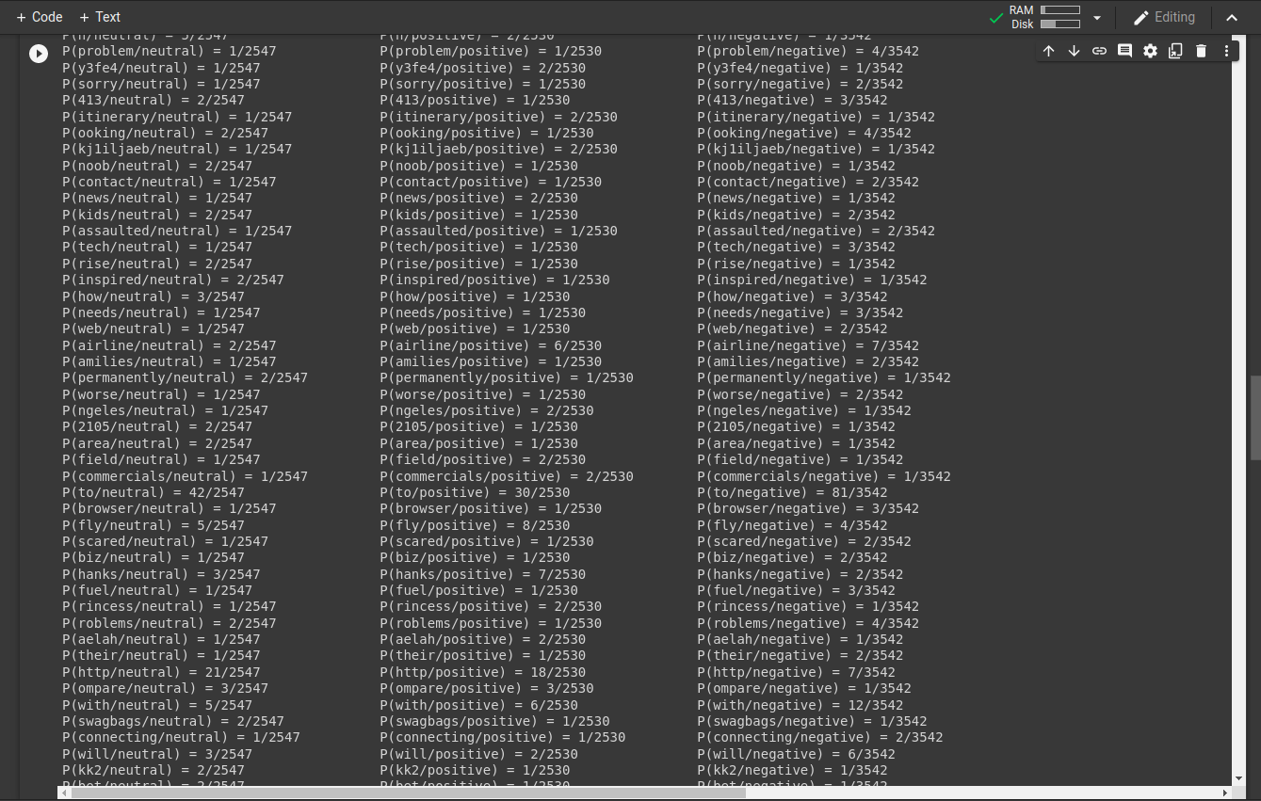

**CODE:**

# Importing the libraries

import numpy as np

import matplotlib.pyplot as plt

import pandas as pd

# Importing the dataset

dataset = pd.read_csv('Tweets Dataset.csv')

X = dataset.iloc[:,[2,9]].values

y = dataset.iloc[:,1].values

# Splitting the dataset into the Training set and Test set

from sklearn.model_selection import train_test_split

X_train, X_test, y_train, y_test = train_test_split(X, y, test_size = 0.20, random_state = 0)

# Feature Scaling

from sklearn.preprocessing import StandardScaler

sc = StandardScaler()

X_train = sc.fit_transform(X_train)

X_test = sc.transform(X_test)

# Training the Naive Bayes model on the Training set

from sklearn.naive_bayes import GaussianNB

classifier = GaussianNB()

classifier.fit(X_train, y_train)

# Predicting the Test set results

y_pred = classifier.predict(X_test)

print(y_pred)

# Making the Confusion Matrix

from sklearn.metrics import confusion_matrix, accuracy_score

ac = accuracy_score(y_test,y_pred)

cm = confusion_matrix(y_test, y_pred)

print("Accuracy",ac)

print("Confusion Matrix",cm)

**OUTPUT:**

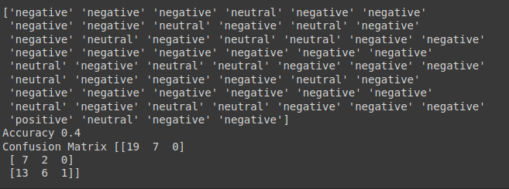

1. Implement a suitable community detection algorithm for the detection and analysis of community structure for the following network graph datasets. Show the communities using graph coloring technique.

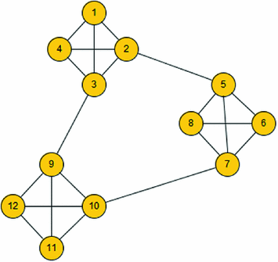

**CODE:**

import networkx as nx

from matplotlib import pyplot as plt

from networkx.algorithms.community.centrality import girvan_newman

adjacency_matrix=[

[0,1,1,1,0,0,0,0,0,0,0,0],

[1,0,1,1,1,0,0,0,0,0,0,0],

[1,1,0,1,1,0,0,0,1,0,0,0],

[1,1,1,0,0,0,0,0,0,0,0,0],

[0,1,0,0,0,1,1,1,0,0,0,0],

[0,0,0,0,1,0,1,1,0,0,0,0],

[0,0,0,0,1,1,0,1,0,1,0,0],

[0,0,0,0,1,1,1,0,0,0,0,0],

[0,0,1,0,0,0,0,0,0,1,1,1],

[0,0,0,0,0,0,1,0,1,0,1,1],

[0,0,0,0,0,0,0,0,1,1,0,1],

[0,0,0,0,0,0,0,0,1,1,1,0]

]

num_vertices = 12

vertices_list = ['1','2','3','4','5','6','7','8','9','10','11','12']

graph = nx.DiGraph()

# Load the nodes into the graph

graph.add_nodes_from(vertices_list)

# Add the edges from the adjacency matrix

for i inrange(num_vertices):

for j inrange(num_vertices):

if adjacency_matrix[i][j] == 1:

graph.add_edge(vertices_list[i], vertices_list[j])

# Draw generated graph

nx.draw_networkx(graph, pos=nx.circular_layout(graph), arrows=True, with_labels= True)

plt.show()

communities = girvan_newman(graph)

node_groups = []

for com innext(communities):

node_groups.append(list(com))

print(node_groups)

color_map = []

for node in graph:

if node in node_groups[0]:

color_map.append('red')

else:

color_map.append('yellow')

graph = nx.draw_networkx(graph,node_size=600,node_color=color_map)

plt.show()

**OUTPUT:**

